该栏由学校填写
This is to be filled out
by the university
编 号
学 院
授课语言
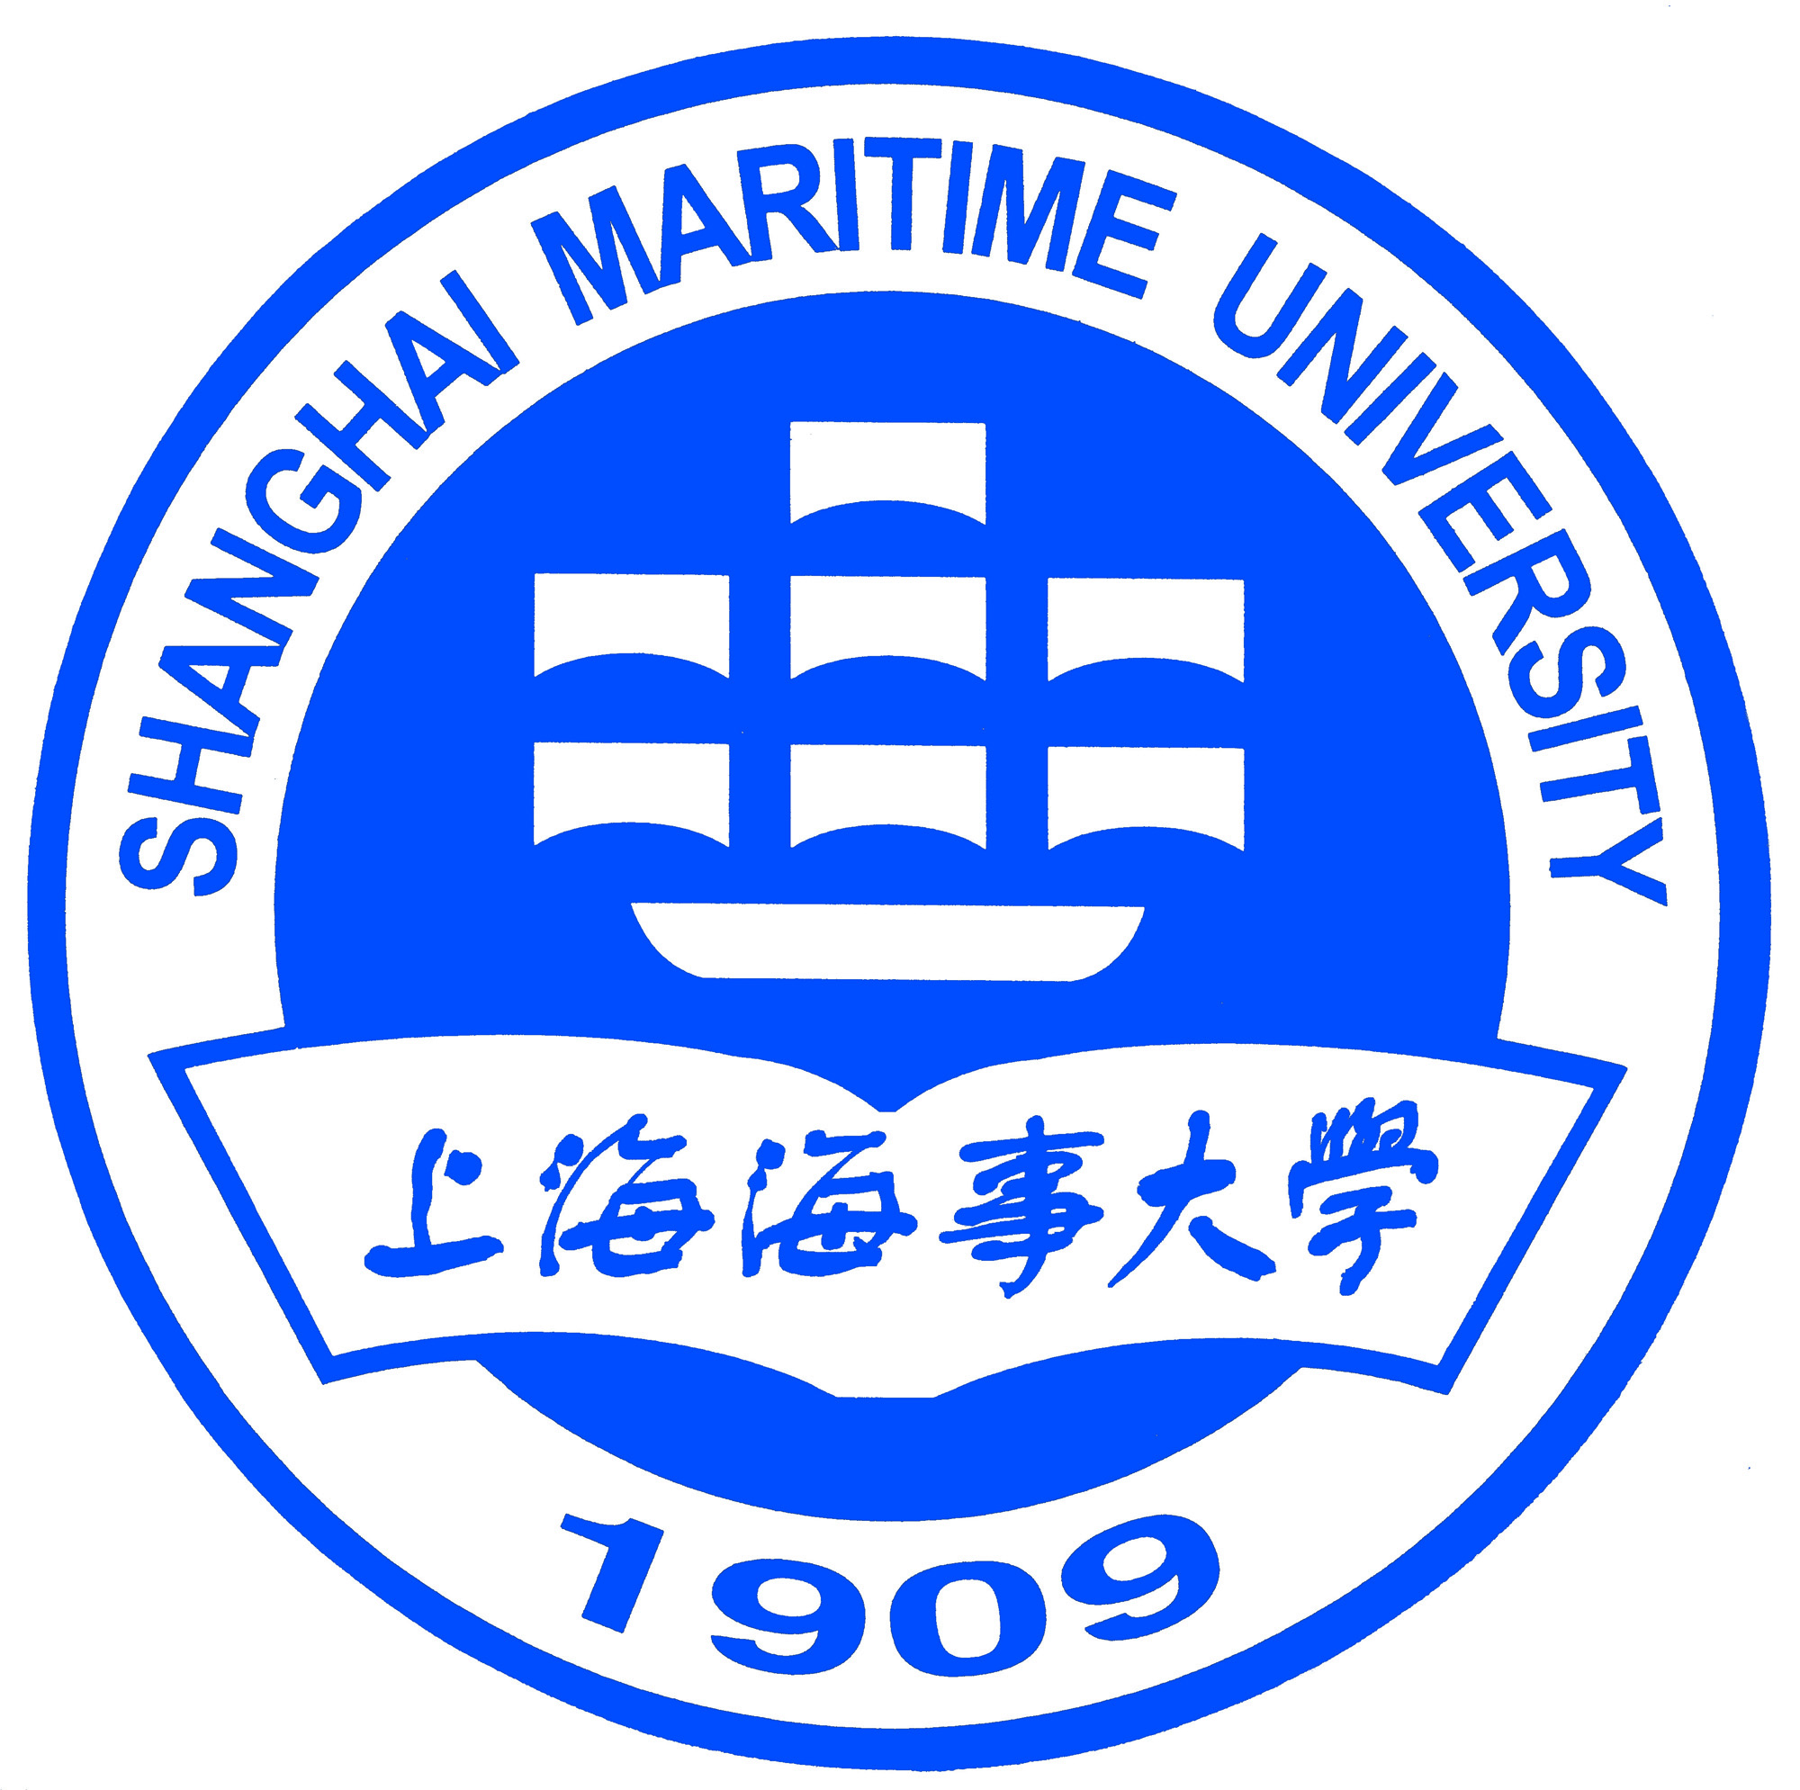

外国留学生入学申请表
Application Form for International Students at
Shanghai Maritime University

注意：请申请人用中文或英文清楚地填写以下诸项，并打印。不接受手写。不能缺项填写，没有的请写“无”。
Please print all the information requested. Handwriting is not acceptable. Please write None if not applicable.
护照姓/ Passport  Surname |  |  |  |  |  |  |  | 护照名/ Passport  Given Name |  |  |  |  |  |  |  |  |  | 照片  Photo
中文姓名  Chinese Name |  |  |  |  | 国籍  Nationality |  |  |  |  |  |  |  | 性别  Sex |  | □ 男/Male  □女/Female
婚姻状况  Marital Status | - 已婚/ Married  - 未婚/ Single |  |  |  |  | 护照信息  Passport Info. |  |  |  |  | 号码/Passport No.:  有效期/Valid Until: 年yy 月mm 日dd
出生日期  Date of Birth | 年yy 月mm 日dd |  |  |  |  |  | 出生地  Place of Birth
职业  Current Occupation |  |  |  |  |  |  |  |  |  | 现工作和学习单位  Employer/Institute
电话、手机  Tel / Cell Phone |  |  |  |  |  |  |  |  |  | 电子邮件  Email
永久通讯地址  Permanent Home Address |  |  |  |  |  |  |  |  |  |  |  |  |  | 邮政编码  Zip Code
电话  Telephone |  |  |  |  |  |  | 传真  Fax |  |  |  |  |  |  | 宗教信仰  Religion
语言能力  Language Proficiency |  |  | 汉语水平/Chinese proficience：新HSK 级(Level) 分(score)；旧HSK 级(Level)  英语水平/English proficience： TOFEL ；IELTS ；  母语/Mother Tongue: ; 其他语言/Other Languages:
教育背景（从中学开始填起） Education Background（From High School）
学校名称  Institutions |  |  | 在校时间  Years attended (from/to) |  |  |  |  |  | 主修专业Field of study |  |  |  |  |  |  | 所获证书Diploma received
 |  |  | -----
 |  |  | -----
 |  |  | -----
 |  |  | -----
工作经历 Working Experience
工作单位  Employer |  |  | 起止时间  Years attended (from/to) |  |  |  |  |  | 从事工作  Occupation |  |  |  |  |  |  | 职务  Position
 |  |  | -----
 |  |  | -----
在上海海事大学的学习计划Study Plan at SMU
是否学习过汉语  Did you have Chinese Training? |  |  | □是/Yes □否/No 如果是，学习期间为：  If Yes, then the study duration is: From yy mm to yy mm。
申请类别  Applying as |  |  | □本科生/Undergraduate □硕士/Master Student □博士/Doctoral Student  □汉语学习/Chinese Study Student □普通进修/General Visiting Student □高级进修/Senior Visiting Student
申请专业1/Major 1： |  |  |  |  |  |  |  |  |  |  |  | 申请专业2/Major 2：
申请学习时间Duration of Study:  自From 年yy 月mm 至To 年yy 月mm |  |  |  |  |  |  |  |  |  |  |  | 是否服从调剂Accept other majors or not:  □是/Yes □否/No
住宿申请  Accommodation Application |  |  |  | - 无需通过学校安排住宿/ No need for accommodation arrangement by SMU  - 申请宿舍/ Applying for accommodation on campus  □单人间/ Single room □ 双人间/ Double room  预计入住时间/ Expected Move-in on yy/mm/dd  其他要求/Other requirements:
申请人保证/I hereby affirm that:
1)上述各项中所填写的内容和提供的材料真实无误；
All information and materials provided here are true and correct.
2)在华期间，遵守中国的法律和法规，不从事任何危害中国社会秩序的，与本人来华学习身份不相符合的活动；
During my stay in China, I shall abide by the laws and decrees of the Chinese government, and will not participate in any activities which are deemed to be adverse to the social order in China and are inappropriate to the capacity as a student;
3)在学期间，遵守学校的校纪校规，尊重学校的教学安排。
During my study in China, I shall observe the rules and regulations of the university, and will concentrate on my studies and researches, and will follow the teaching programs provided by the university.
申请人签字（Applicant’s Signature）：____________________________ 日期Date：_________________
(无此签名，申请无效。The application is invalid without the signature.)
申请人在提交本表时，请同时提交 Applicant should also submit the followings documents.
- 高中以上毕业证书 （1）Diploma and degree
- 成绩单 （2）Related transcripts
- 英语或汉语水平证书 （3）English or Chinese Level Certificate
- 护照复印件 （4）Valid passport copy
- 两张照片 （5）Two passport-sized photos
- 报名费 （6）Application Fee
上海海事大学国际教育学院 International Education College,SMU email: iec@shmtu.edu.cn;iecsmu@163.com
临港校区地址：上海市临港新城海港大道1550号
Lingang Campus Add: 1550 Haigang Avenue, New Harbor City, Shanghai, China
邮编/Zip Code：201306
电话/Tel：86-21-38284998/4990/4997
传真/ Fax：86-21-38284999
东明校区地址：上海市浦东东明路1336号
Doming Campus: 1336 Dongming Road, Shanghai,China
邮编/Zip Code：200126
电话/Tel：86-21-50280042
传真/ Fax：86-21-50280042

